DESIGN AND ANALYSIS OF ALGORITHMS – ASSIGNMENT 1

Algorithms Selected
- Linear Search – Iterative
- Binary Search – Recursive
- Hash Table Search – Direct lookup

TASK 1 – DESIGN THE ALGORITHM

1. Linear Search

Basic Idea
Linear Search checks each registration number one by one until the required registration number is found.

Design Strategy
Brute-force / sequential search

Preprocessing
No preprocessing is required.

Pseudocode

LINEAR_SEARCH(A, key)

1. FOR i ← 0 TO n-1

2. IF A[i] = key

3. RETURN i

4. RETURN -1

Justification
Linear Search is simple and works directly on unsorted data. It is useful as a baseline for comparison.

2. Recursive Binary Search

Basic Idea
Binary Search works on sorted data. It compares the key with the middle element and recursively searches only the required half.

Design Strategy
Divide and Conquer

Preprocessing
The records must be sorted first.

Pseudocode

BINARY_SEARCH(A, low, high, key)

1. IF low > high

2. RETURN -1

3. mid ← (low + high) / 2

4. IF A[mid] = key

5. RETURN mid

6. IF key < A[mid]

7. RETURN BINARY_SEARCH(A, low, mid-1, key)

8. ELSE

9. RETURN BINARY_SEARCH(A, mid+1, high, key)

Justification
Binary Search is suitable for large sorted datasets because it reduces the search space by half at every step.

3. Hash Table Search

Basic Idea
A hash table stores each registration number using a hash function. Searching calculates the hash and directly accesses the required location.

Design Strategy
Hashing / Direct Access

Preprocessing
The records must be inserted into a hash table.

Pseudocode
HASH_SEARCH(H, key)
1. index ← HASH(key)
2. IF H[index] = key
3. RETURN FOUND
4. ELSE
5. RETURN NOT FOUND

Justification
Hashing provides very fast average search time and is suitable when many searches are performed on a large database.
The assignment specifically requires preprocessing to be considered in the analysis.
TASK 2 – IDENTIFY THE BASIC OPERATION
Algorithm | Basic Operation | Location
Linear Search | Key comparison | A[i] = key
Binary Search | Middle-element comparison | A[mid] = key
Hash Search | Hash/index lookup | HASH(key)

Linear Search
The main operation is comparison between the search key and each array element. As n increases, the number of comparisons can increase linearly.

Binary Search
The main operation is comparison with the middle element. Each comparison eliminates approximately half of the remaining elements.

Hash Search
The main operation is calculating the hash/index and checking the corresponding location. With a good hash function, the average number of operations remains nearly constant.

TASK 3 – MATHEMATICAL TIME-COMPLEXITY ANALYSIS

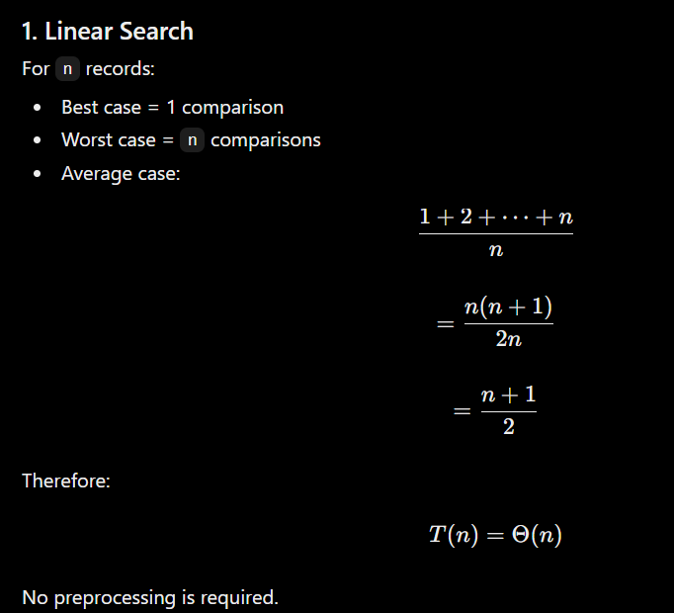
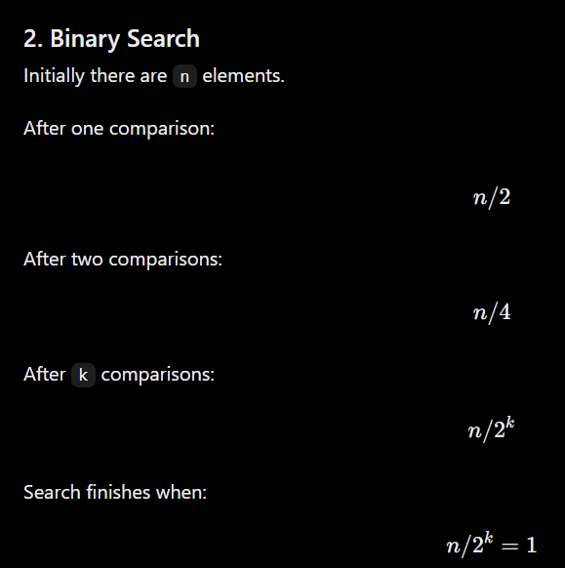
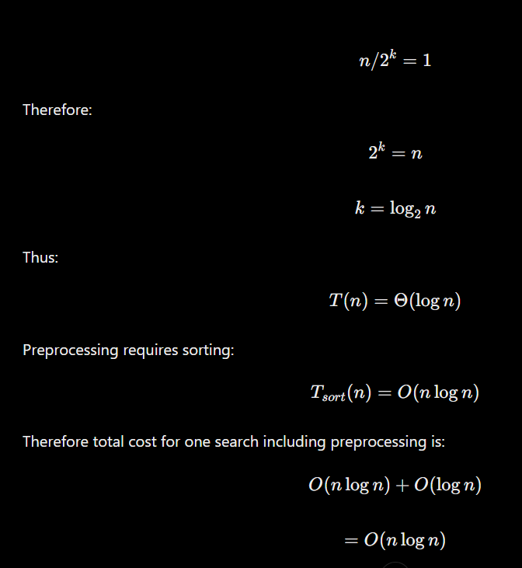

TASK 4 – BEST, AVERAGE AND WORST CASE

Linear Search
Best case: Key is the first element.
Average case: Key is located around the middle.
Worst case: Key is the last element or is absent.

Binary Search
Best case: Key is the middle element.
Average case: Several divisions are required.
Worst case: Key is absent or found after maximum divisions.

Hash Search
Best case: Key maps directly to an empty/non-colliding location.
Average case: Few collisions occur.
Worst case: Many keys collide, causing several comparisons.

TASK 5 – ASYMPTOTIC ANALYSIS

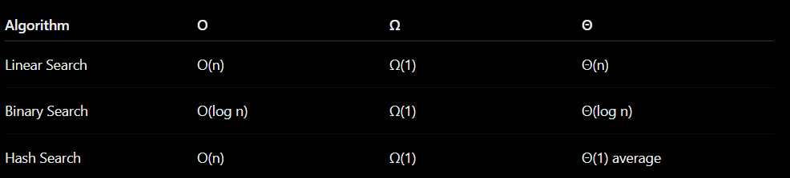
For very large datasets, Binary Search grows much more slowly than Linear Search.
Hash Search provides the best average search complexity, provided that the hash table has a suitable size and good hash function.
For example, when the dataset increases from 1,000 to 1,000,000 records, linear growth becomes expensive, while logarithmic growth increases much more slowly. The assignment asks this comparison specifically for the growth to 1,000,000+ records.

TASK 6 – Recurrence Relation
For Recursive Binary Search:
- Problem size = n
- Subproblem size = n/2
- Recursive calls = 1
- Extra work = c
- Base case = T(1) = c
Recurrence:
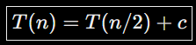
Therefore:
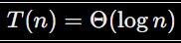
TASK 7 – SOLVE RECURRENCE
Using Master Theorem:
Here,
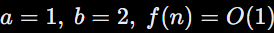
Therefore,
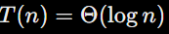

TASK 8 – IMPLEMENTATION & TESTING
Test the three algorithms with:
- 1,000 records
- 10,000 records
- 100,000 records
- 1,000,000 records
Test:
Reg No → FOUND
Reg No + 1 → NOT FOUND

TASK 9 – EXPERIMENTAL PERFORMANCE
Size | Linear | Binary | Hash
1K | Actual time | Actual time | Actual time
10K | Actual time | Actual time | Actual time
100K | Actual time | Actual time | Actual time
1M | Actual time | Actual time | Actual time
Measure time and comparisons and create graphs.
TASK 10 – THEORY VS EXPERIMENT
- Linear Search → \(\Theta(n)\)
- Binary Search → \(\Theta(\log n)\)
- Hash Search → \(\Theta(1)\) average
As n increases, Hash Search and Binary Search perform better than Linear Search.

TASK 11 – FINAL RECOMMENDATION
Recommended: Hash Table Search
- Average search: \(O(1)\)
- Suitable for 1M records
- Fast for repeated searches
- Daily updates are manageable



TASK 12 – DESIGN CHALLENGE
Requirement: 50,000 searches/hour and 1M records.
A. Impact: Search frequency is high, but updates are only daily.
B. Evaluation: Hash Search remains suitable.
C. Decision: Modify and retain Hash Table.
Complexity:
D. Defence: Hash Search is best because it supports a large number of searches efficiently.

TASK 12 – DAY-4 DESIGN CHALLENGE
A. Impact Analysis
- 50,000 searches/hour
- 1,000,000 records
- Updates only once per day
- High search frequency requires faster searching.
B. Evaluation
Hash Table remains suitable.
Average Search=O(1)
Preprocessing=O(n)
C. Adaptation
Decision: Modify and retain Hash Table.
Records → Hash Table → Daily Update → Fast Search
D. Defence
Hash Search is preferred because it is faster for frequent searches and suitable for 1 million records.
Final Design: Hash Table Search

Final Comparison
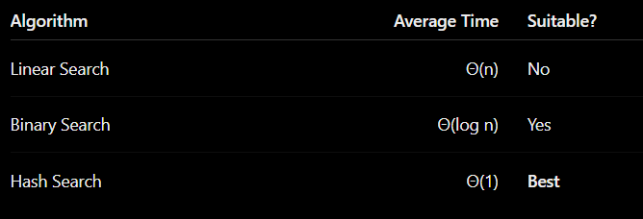
Conclusion
For small datasets, Linear Search is simple and requires no preprocessing. Binary Search is much faster for sorted data because it reduces the search space by half. Hash Table Search provides the best average lookup performance and is particularly suitable for the changed requirement of 50,000 searches per hour on 1,000,000 records.

